**CH10 E-commerce: Digital Markets, Digital Goods**

學習目標

* 1. 電子商務，數位市場和數位商品的獨特功能是什麼？
  2. 電子商務的主要業務和收入模式是什麼？
  3. 電子商務如何改變營銷？
  4. 電子商務如何影響企業對企業(B2B)的交易？
  5. 行動商務在企業中的作用是什麼，最重要的行動商務應用是什麼？
  6. 建立電子商務機構時必須解決哪些問題？
* Do you think Uber’s business model is viable? Why or why not? How do you feel about using Uber compared with a regulated taxi?

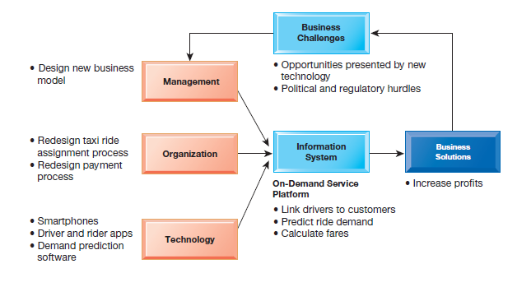

1. What are the unique features of e-commerce, digital markets, and digital goods?
   * E-commerce Today

* E-commerce
* use of the Internet and the web to transact business.
* digitally enabled commercial transactions between and among organizations and individuals
* transactions that occur over the Internet and the web
* Began in 1995 and grew exponentially; still stable even in a recession.
* Companies that survived the dot-com bubble now thrive
* Amazon, eBay, Expedia, and Google
* By 2006, e-commerce revenues returned to solid growth, and have continued to be the fastest-growing form of retail trade in the United States, Europe, and Asia.

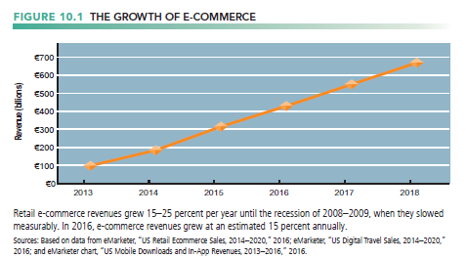

* + The New E-commerce: Social, Mobile, Local
* Preface
* One of the biggest changes is the extent to which e-commerce has become more social, mobile, and local.
* Online marketing once consisted largely of creating a corporate website, buying display ads on Yahoo, purchasing ad words on Google, and sending e-mail messages.
* The primary measure of success was how many eyeballs (unique visitors) a website produced and how many impressions a marketing campaign generated. (An impression was one ad shown to one person.)
* From Eyeballs to Conversations: Conversational Commerce
* Marketing in this new period is based on firms engaging in multiple online conversations with their customers, potential customers, and even critics
* Social marketing means all things social: listening, discussing, interacting, empathizing, and engaging
* social marketing is not simply a new ad channel but a collection of technology-based tools for communicating with shoppers.
* From the Desktop to the Smartphone
* As mobile devices become more powerful, they are more useful for accessing Facebook and other social sites.
* customers can use them to find local merchants, and merchants can use them to alert customers in their neighborhood of special offers.
  + Why E-commerce is Different
* Preface

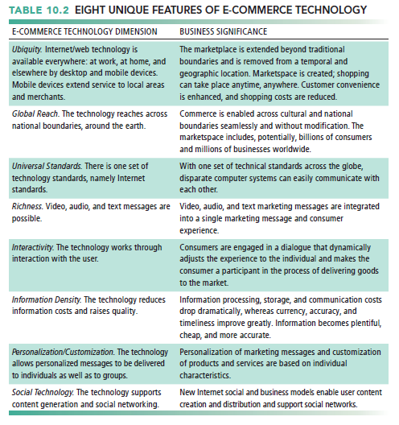

* Ubiquity
* Internet/Web technology available everywhere: work, home, and so on, anytime
* Effect
  + - Marketplace removed from temporal, geographic locations to become “marketspace”
    - Enhanced customer convenience and reduced shopping costs
* Reduces transaction costs
  + - Costs of participating in market
* Global Reach
* The technology reaches across national boundaries, around Earth
* Effect
  + - Commerce enabled across cultural and national boundaries seamlessly and without modification.
    - Marketspace includes, potentially, billions of consumers and millions of businesses worldwide.
* Universal Standards
* One set of technology standards: Internet standards
* Effect
  + - Disparate computer systems easily communicate with one another
    - Lower market entry costs—costs merchants must pay to bring goods to market
    - Lower consumers’ search costs—effort required to find suitable products
* Richness
* Information richness refers to the complexity and content of a message
* Effect
  + - Possible to deliver rich messages with text, audio, and video simultaneously to large numbers of people.
    - Video, audio, and text marketing messages can be integrated into single marketing message and consumer experience.
* Interactivity
* meaning they allow for two-way communication between merchant and consumer and peer-to-peer communication among friends.
* Effect
  + - Consumers engaged in dialog that dynamically adjusts experience to the individual.
    - Consumer becomes co-participant in process of delivering goods to market.
* Information Density
* Large increases in information density—the total amount and quality of information available to all market participants
* Effect
  + - Greater price transparency
    - Greater cost transparency
    - Enables merchants to engage in price discrimination—selling the same goods, or nearly the same goods, to different targeted groups at different prices.
* Personalization/Customization
* changing the delivered product or service based on a user’s preferences or prior behavior.
* Effect
  + - Personalized messages can be sent to individuals as well as groups.
    - Products and services can be customized to individual preferences.
* Social Technology: User Content Generation and Social Networking
* The technology promotes user content generation and social networking
* The new Internet and e-commerce empower users to create and distribute content on a large scale and permit users to program their own content consumption.
* Internet provides a unique many-to-many model of mass communications.
* Effect
  + - New Internet social and business models enable user content creation and distribution, support social networks
    - Many-to-many model
  + Key Concepts in E-commerce: Digital Markets and Digital Goods in a Global Marketplace
* Effect of the Internet on the marketplace
* Reduces information asymmetry
* has changed the way companies conduct business and increased their global reach.
* Offers greater flexibility and efficiency because of
  + - Reduced search costs and transaction costs
    - Lower menu costs
    - Greater price discrimination
    - Dynamic pricing
* May reduce or increase switching costs
* May delay gratification: effects dependent on product
* Increased market segmentation
* Stronger network effects
* More disintermediation

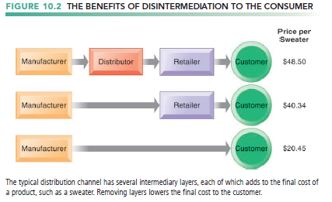

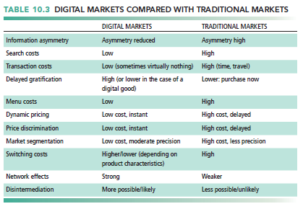

* Digital Goods
* Goods that can be delivered over a digital network
  + - For example: music tracks, video, software, newspapers, books
* Cost of producing first unit is almost entire cost of product
* Costs of delivery over the Internet very low
* Marketing costs remain the same; pricing highly variable
* Industries with digital goods are undergoing revolutionary changes (publishers, record labels, etc.)

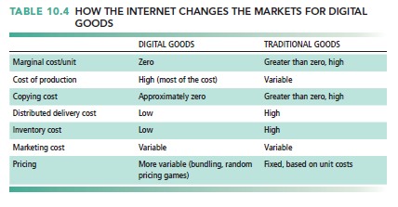

1. What are the principal e-commerce business and revenue models?
   * Types of E-commerce

* Business-to-consumer (B2C)
* retailing products and services to individual shoppers.
* Amazon, Walmart, and iTunes
* Business-to-business (B2B)
* involves sales of goods and services among businesses.
* Elemica
* Consumer-to-consumer (C2C)
* involves consumers selling directly to consumers.
* eBay
* E-commerce can be categorized by platform
* Mobile commerce (m-commerce)
  + E-commerce Business Models
* Portal
* gateways to the web and are often defined as those sites that users set as their home page
* E-tailer
* similar to the typical bricks-and-mortar storefront, except that customers only need to connect to the Internet to check their inventory and place an order.
* Amazon
* Content Provider
* Content is defined broadly to include all forms of intellectual property.
* Content providers distribute information content—such as digital video, music, photos, text, and artwork—over the web.
* The value proposition of online content providers is that consumers can conveniently find a wide range of content online and purchase this content inexpensively to be played or viewed on multiple computer devices or smartphones.
* Podcasting is a method of publishing audio or video broadcasts through the Internet, allowing subscribing users to download audio or video files onto their personal computers, smartphones, tablets, or portable music players.
* Streaming is a publishing method for music and video files that flows a continuous stream of content to a user’s device without being stored locally on the device.
* Transaction Broker
* primary value propositions are savings of money and time and providing an extraordinary inventory of financial products and travel packages in a single location.
* Fidelity Financial Services and Expedia
* Market Creator
* Market creators build a digital environment in which buyers and sellers can meet, display products, search for products, and establish prices.
* The value proposition of online market creators is that they provide a platform where sellers can easily display their wares and purchasers can buy directly from sellers.
* Service Provider
* Whereas e-tailers sell products online, service providers offer services online.
* increasingly, software as a service (SaaS) that you subscribe to online rather than purchase from a retailer, such as Office 365
* Community Provider (Social Networks)
* create a digital online environment where people with similar interests can transact; share interests, photos, videos; communicate with like-minded people; receive interest-related information; and even play out fantasies by adopting online personalities called avatars
  + E-commerce Revenue Models
* Preface
* A firm’s revenue model describes how the firm will earn revenue, generate profits, and produce a superior return on investment.
* most companies rely on one, or some combination, of the following six revenue models
* Advertising Revenue Model
* a website generates revenue by attracting a large audience of visitors who can then be exposed to advertisements.
* the most widely used revenue model in e-commerce
* Sales Revenue Model
* companies derive revenue by selling goods, information, or services to customers
* Amazon, LLBean.com, Gap.com
* Micropayment systems
  + - provide content providers with a cost-effective method for processing high volumes of very small monetary transactions
* Apple’s iTunes Store
* Subscription Revenue Model
* a website offering content or services charges a subscription fee for access to some or all of its offerings on an ongoing basis.
* Ancestry.com and Genealogy.com (genealogy research), and Microsoft Xbox Live.
* Free/Freemium Revenue Model
* firms offer basic services or content for free and charge a premium for advanced or special features.
* Spotify
* Transaction Fee Revenue Model
* a company receives a fee for enabling or executing a transaction.
* For example, eBay provides an online auction marketplace and receives a small transaction fee from a seller if the seller is successful in selling an item.
* The transaction revenue model enjoys wide acceptance in part because the true cost of using the platform is not immediately apparent to the user.
* Affiliate Revenue Model
* websites (called affiliate websites) send visitors to other websites in return for a referral fee or percentage of the revenue from any resulting sales.
* Referral fees are also referred to as lead generation fees.
* Amazon uses affiliates that steer business to the Amazon website by placing the Amazon logo on their blogs.

1. How has e-commerce transformed marketing?
   * Preface

* The Internet provides marketers with new ways of identifying and communicating with millions of potential customers at costs far lower than traditional media, including search engine marketing, data mining, recommender systems, and targeted e-mail.
* long tail marketing
* Ability to reach a large audience inexpensively
* Internet advertising formats

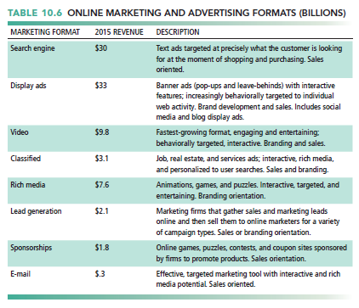

* + Behavioral Targeting
* tracking the clickstreams (history of clicking behavior) of individuals on thousands of websites to understand their interests and intentions and expose them to advertisements that are uniquely suited to their online behavior.
* Behavioral targeting takes place at two levels
* at individual websites or from within apps
* on various advertising networks that track users across thousands of websites.

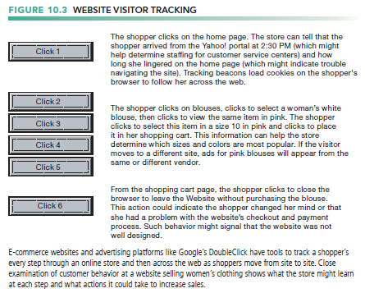

* This information enables firms to understand how well their website is working, create unique personalized web pages that display content or ads for products or services of special interest to each user, improve the customer’s experience, and create additional value through a better understanding of the shopper

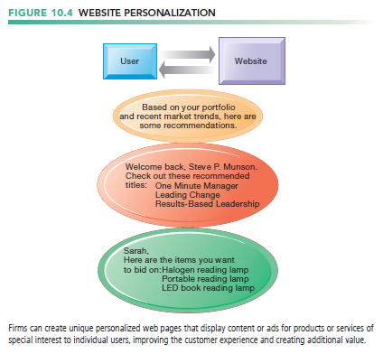

* Ad networks create real-time bidding platforms (RTB) where marketers bid in an automated environment for highly targeted slots available from web publishers.
* ad platforms can predict how many targeted individuals will view the ads, and ad buyers can estimate how much this exposure is worth to them.
* advertising exchanges use this same technology to auction access to people with very specific profiles to advertisers in a few milliseconds.

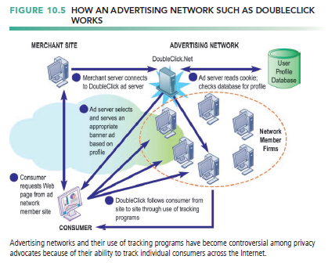

* Native advertising involves placing ads in social network newsfeeds or within traditional editorial content, such as a newspaper article.
* This is also referred to as organic advertising, where content and advertising are in very close proximity or integrated together.
  + Social E-Commerce and Social Network Marketing
* Preface
* Social e-commerce
  + - commerce based on the idea of the digital social graph, a mapping of all significant online social relationships.
* The social graph
  + - synonymous with the idea of a social network used to describe offline relationships.
* Features of social e-commerce driving its growth

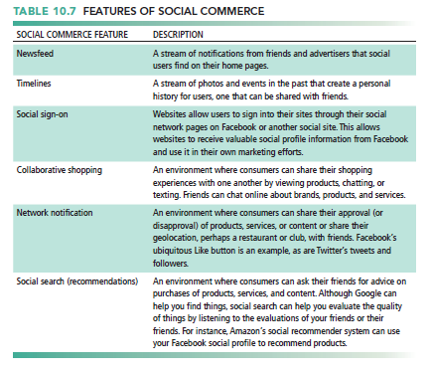

* Social media
  + - Fastest growing media for branding and marketing
* Social network marketing
  + - Seeks to leverage individuals influence over others in social graph
    - The target is a social network of people sharing interests and advice
    - Facebook’s “Like button”
    - Social networks have huge audiences
* social shopping sites
  + - you can swap shopping ideas with friends
* At social shopping sites such as Online communities are also ideal venues to employ viral marketing techniques.
* The Wisdom of Crowds
* some argue that large numbers of people can make better decisions about a wide range of topics or products than a single person or even a small committee of experts.
* Crowdsourcing
* Large numbers of people can make better decisions about topics and products than a single person.
* Prediction markets
* Peer-to-peer betting markets on specific outcomes (elections, sales figures, designs for new products)

1. How has e-commerce affected business-to-business transactions?
   * Preface

* The total amount of B2B trade in the United States in 2015 was estimated to be about $14.6 trillion, with B2B e-commerce (online B2B) contributing about $6.2 trillion of that amount
* By 2019, B2B e-commerce is expected to grow to about $8.6 trillion in the United States.
  + Electronic Data Interchange (EDI)
* About 80 percent of online B2B e-commerce is still based on proprietary systems for Electronic Data Interchange (EDI)
* Computer-to-computer exchange of standard transactions such as invoices, purchase orders.
* Major industries have EDI standards that define structure and information fields of electronic documents
* Each major industry in the United States and much of the rest of the world has EDI standards that define the structure and information fields of electronic documents for that industry.

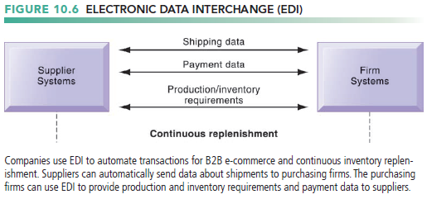

* Although many organizations still use private networks for EDI, they are increasingly web-enabled because Internet technology provides a much more flexible and low-cost platform for linking to other firms.
  + New Ways of B2B Buying and Selling
* Private industrial networks(private exchange)
* Large firm using extranet to link to its suppliers, distributors, and other key business partners
* The buyer owns the network, and it permits the firm and designated suppliers, distributors, and other business partners to share product design and development, marketing, production scheduling, inventory management, and unstructured communication

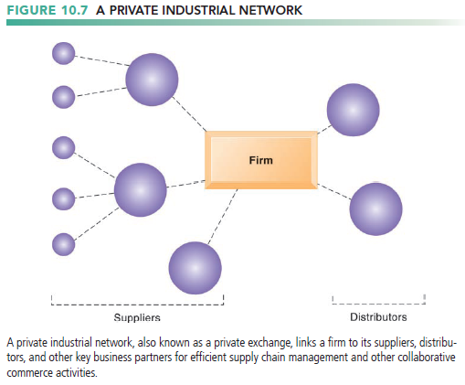

* Net marketplaces(e-hubs)
* provide a single, digital marketplace based on Internet technology for many buyers and sellers
* industry-owned or operate as independent intermediaries between buyers and sellers.
* generate revenue from purchase and sale transactions and other services provided to clients.
* Use prices established through negotiation, auction, RFQs, or fixed prices
* sell direct goods
  + - goods used in a production process
* sell indirect goods
  + - all other goods not directly involved in the production process
* Some Net marketplaces serve vertical markets for specific industries, whereas others serve horizontal markets for goods and services
* Exchanges
  + - independently owned third-party Net marketplaces
    - Connect thousands of suppliers and buyers for spot purchasing
    - Typically provide vertical markets for direct goods for single industry (food, electronics)
    - Exchanges proliferated during the early years of e-commerce, but many have failed.
    - Competitive bidding drove prices down and did not offer long-term relationships with buyers or services to make lowering prices worthwhile.

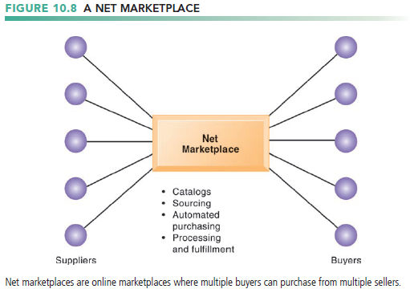

1. What is the role of m-commerce in business, and what are the most important m-commerce applications?
   * Preface

* In 2017 is 37 percent of all e-commerce
* Fastest growing form of e-commerce
* expanding at a rate of 50 percent or more per year, and is estimated to grow to $300 billion by 2020
* The main areas of growth in mobile e-commerce are mass market retailing, sales of digital content

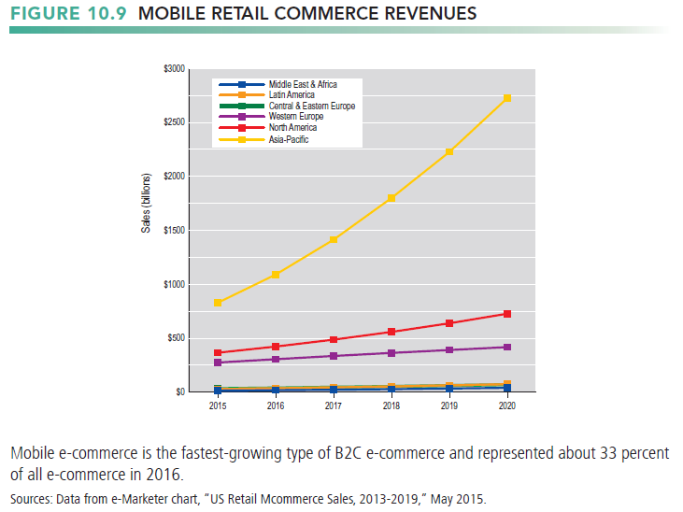

* + Location-Based Services and Applications
* Location-based services include geosocial, geoadvertising, and geoinformation services.
* Used by 74 percent of smartphone owners
* Based on GPS map services
* Types
* A geosocial service
  + - where your friends are meeting
* Geoadvertising services
  + - What shops are nearby
* Geoinformation services
  + - Price of house you are passing
  + Other Mobile Commerce Services
* Banks, credit card companies provide account management apps
* Mobile display advertising
* iAd, AdMob, Millenial Media, Facebook
* Ads embedded in games, videos, and mobile apps
* 55 percent of online retailers have m-commerce Web sites
* In 2016, more than half of m commerce sales occurred within apps rather than mobile web browsers.

1. What issues must be addressed when building an e-commerce presence?
   * Preface

* The two most important management challenges in building a successful e-commerce presence
* developing a clear understanding of your business objectives
* knowing how to choose the right technology to achieve those objectives.
  + Develop an E-Commerce Presence Map
* E-commerce has moved from being a PC-centric activity on the web to a mobile and tablet-based activity.
* Four areas: Web sites, e-mail, social media, offline media

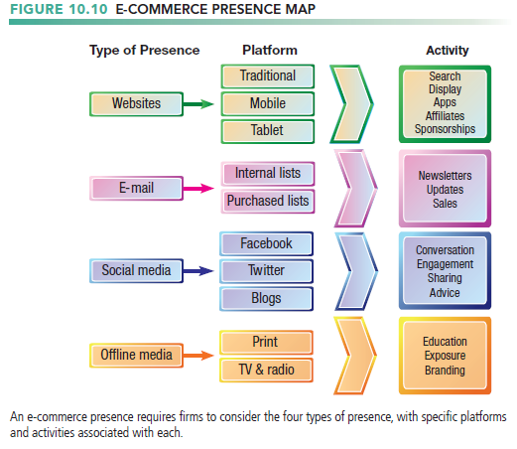

* + Develop a Timeline: Milestones
* break your project down into a small number of phases that could be completed within a specified time.
* 